SQL Tuning Health-Check Script (SQLHC)

Oracle will usually ask for this tool to be run to assist in diagnosing a SQL performance isse. The tool is used to check the environment in which a single SQL Statement runs, checking Cost-based Optimizer (CBO) statistics, schema object metadata, configuration parameters and other elements that may influence the performance of the one SQL being analyzed.

01. Create a directory on the server. I typically use the last node of my RAC where I have space in the backup mount points.

02. Download the SQLHC software from Oracle.

03. The zip archive will look like

[prodsrvr3-RACNODE4] ls -l
total 88
-rw-r--r-- 1 oracle dba 82313 Dec 5 14:35 sqlhc.zip

04. Unzip the file as follows:

[prodsrvr3-RACNODE4] unzip sqlhc.zip
Archive: sqlhc.zip
creating: sqlhc/
inflating: sqlhc/sqlhc.sql
inflating: sqlhc/sqldx.sql
inflating: sqlhc/sqlhcxec.sql

05. After the package is unziped, there will be a directory called sqlhc

[prodsrvr3-RACNODE4] ls -l
total 92
drwx------ 2 oracle dba 4096 Apr 16 2014 sqlhc
-rw-r--r-- 1 oracle dba 82313 Dec 5 14:35 sqlhc.zip

06. cd to that sqlhc directory

[prodsrvr3-RACNODE4] ls -l
total 628
-rw-r--r-- 1 oracle dba 48747 Nov 11 2013 sqldx.sql
-rw-r--r-- 1 oracle dba 288298 Apr 16 2014 sqlhc.sql
-rw-r--r-- 1 oracle dba 292838 Apr 16 2014 sqlhcxec.sql

07. Identify the sqlid of the statement that is causing the issue. In this instance, I used Oracle SQL Developer. The SQL to identify the problem SQL is:

Select inst_id
,sql_id
,sql_text
from gv$sql
where lower(sql_text) like '%rebuild%'
;

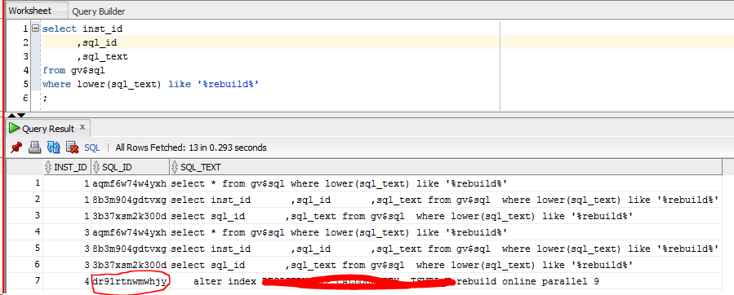

08. Since I have the Oracle tuning license, I am running SQLHC with the "T" option:

[prodsrvr3-RACNODE4] sqlplus / as sysdba

SQL*Plus: Release 11.2.0.3.0 Production on Mon Dec 5 14:51:27 2016

Copyright (c) 1982, 2011, Oracle. All rights reserved.

Connected to:
Oracle Database 11g Enterprise Edition Release 11.2.0.3.0 - 64bit Production
With the Partitioning, Real Application Clusters, Automatic Storage Management, OLAP,
Data Mining and Real Application Testing options

SQL> START sqlhc.sql T dr91rtnwmwhjy

A large amount of information will scroll past the terminal. This could take 5 to 10 minutes. At the end of the process there will be a new zip file created:

[prodsrvr3-RACNODE4] ls -ltr
total 3372
-rw-r--r-- 1 oracle dba 48747 Nov 11 2013 sqldx.sql
-rw-r--r-- 1 oracle dba 288298 Apr 16 2014 sqlhc.sql
-rw-r--r-- 1 oracle dba 292838 Apr 16 2014 sqlhcxec.sql
-rw-r--r-- 1 oracle dba 2805471 Dec 5 15:02 sqlhc_20161205_145218_dr91rtnwmwhjy.zip

09. Upload this file to Oracle within the SR that you probably have open.

10. While Oracle reviews the information, you can take a look also. I downloaded the .zip file to my laptop and extracted the information.

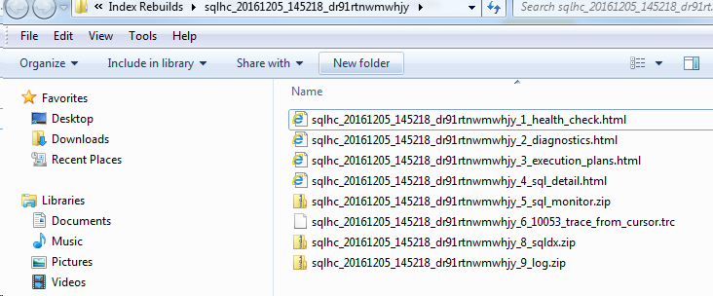

Start by looking at the *_1_health_check.html file. This file contains some "Observations" that are worth taking a look at, implementing and rerunning the SQL to see if there is any improvement.

