Adding disk groups to ASM

Today we had to add some space to a production system. After the storage team provisioned the space and the SA had discovered the space on the LUN, I added the space to ASM. I took some screen prints to document the process using ASMCA. This could have been done via the command line but doing it via ASMCA seems a bit safer.

01. Start MobaXterm for the AMSCA gui

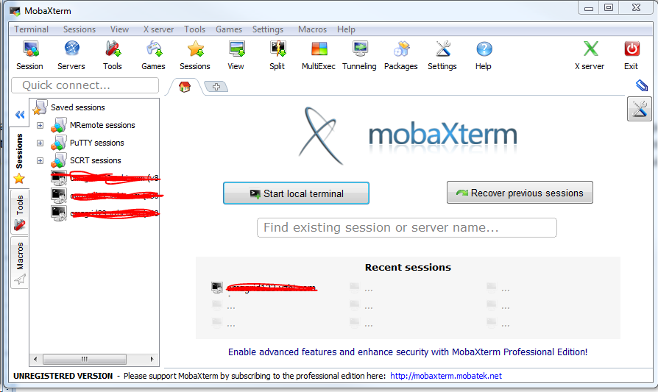

02. Find the IP of my computer

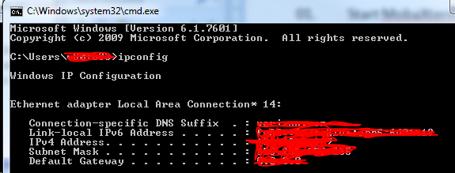

03. Set the display in unix

04. Confirm that you are using the correct version of ASMCA

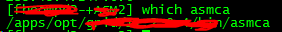

05. Launch ASMCA

06. MobaXterm may ask for permission; click on "Yes"

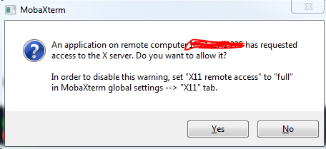

07. Click on the "Disk Groups" tab:

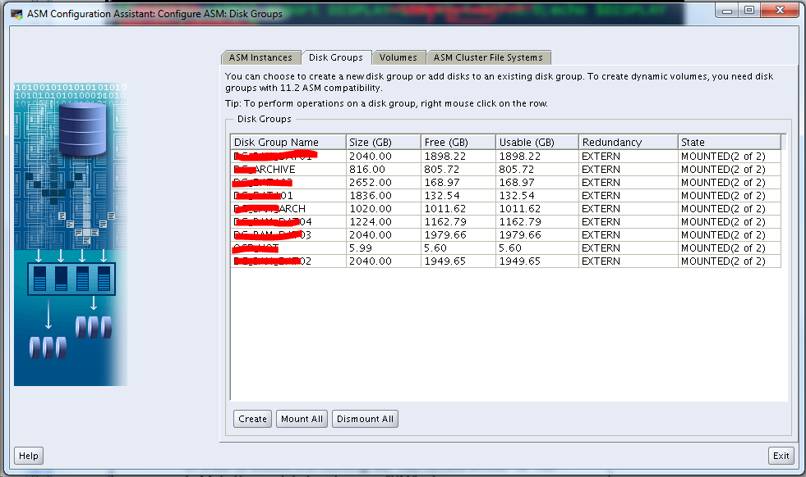

08. Right click on the disk group name that you want to attach storage to and then on add disks:

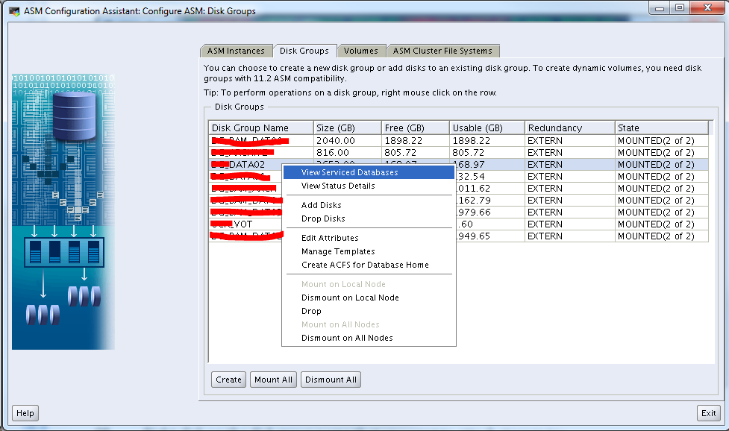

09. "Show Eligible" is checked by default. Click on the disks that you want to add and then click on "ok"

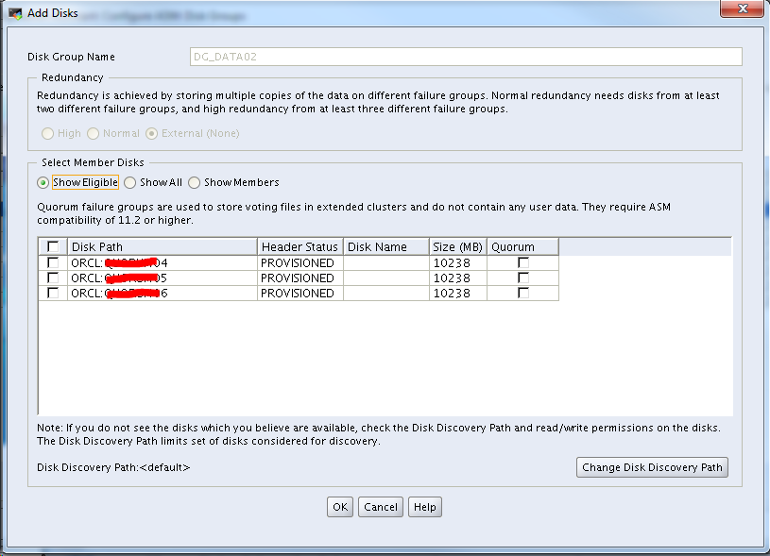

10. Interim message indicating the disk groups are being added:

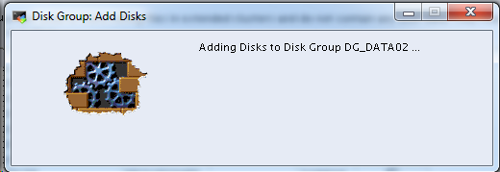

11. Followed by a success message

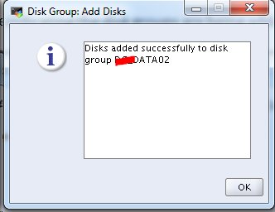

12. Exit from ASMCA

