Checking the use of undo space in the past

We had a circumstance in which we had to delete 4 billion rows from a 5 billion row table. This was done programmatically as we could not take an outage on the system. After the deletes were complete we were attempting to reclaim space on the index on a table, we were attempting to reclaim the space via an online rebuild of the index when we ran out of undo space:

SQL> alter index schema.index_name rebuild online parallel 8;
ERROR at line 1:
ORA-00604: error occurred at recursive SQL level 2
ORA-30036: unable to extend segment by 8 in undo tablespace 'UNDOTBS4'
ORA-30036: unable to extend segment by 8 in undo tablespace 'UNDOTBS4'

Since we had 20gb of space allocated to each instance of the RAC :

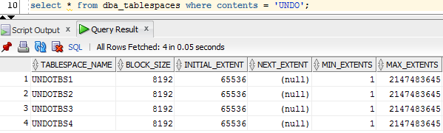

I was curious to get a better understanding of the undo space was used over time, how much was used etc. Since the SQL had failed the night before, there was no point in looking into V$UNDOSTAT and DBA_UNDO_EXTENTS. I had not spent much time looking into DBA_HIST_UNDOSTAT so decided to spend some time today.

My process had a step to email me when it completed (or failed in this case). I received the email at 18:35 mountain time. I ran the below SQL to identify the undo usage at that time:

select new_time(a.begin_time,'GMT','MST') as begin_time_MT
,round(((a.activeBLKS * 8192)/1024/1024),0) as undo_used_mb
,a.INSTANCE_NUMBER
,a.ACTIVEBLKS
,a.UNEXPIREDBLKS
,a.EXPIREDBLKS
,a.*
from DBA_HIST_UNDOSTAT a
where INSTANCE_NUMBER = 4
order by begin_time desc
;

The results of the query were:
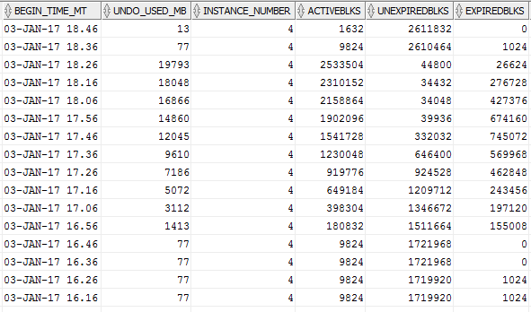

The above shows that at approximately 18:26, all of the undo space was used up. This validated the ORA-30036 message from the process.

